Tour ID: 217356  
Tour Name: 8 Days Self-drive | Around Iceland Ring Road Tour

Tour destinations: ['Keflavik', 'Reykholt', 'Hraunfossar', 'Borgarnes', 'Hvitserkur', 'Siglufjordur', 'Akureyri', 'Godafoss', 'Myvatn', 'Dettifoss', 'Egilsstadir', 'Djupivogur', 'Hofn', 'Jokulsarlon', 'Reynisfjara', 'Skogafoss', 'Hvolsvollur', 'Gullfoss', 'Geysir', 'Thingvellir National Park', 'Reykjavik', 'Blue Lagoon']

Tour destinations images:

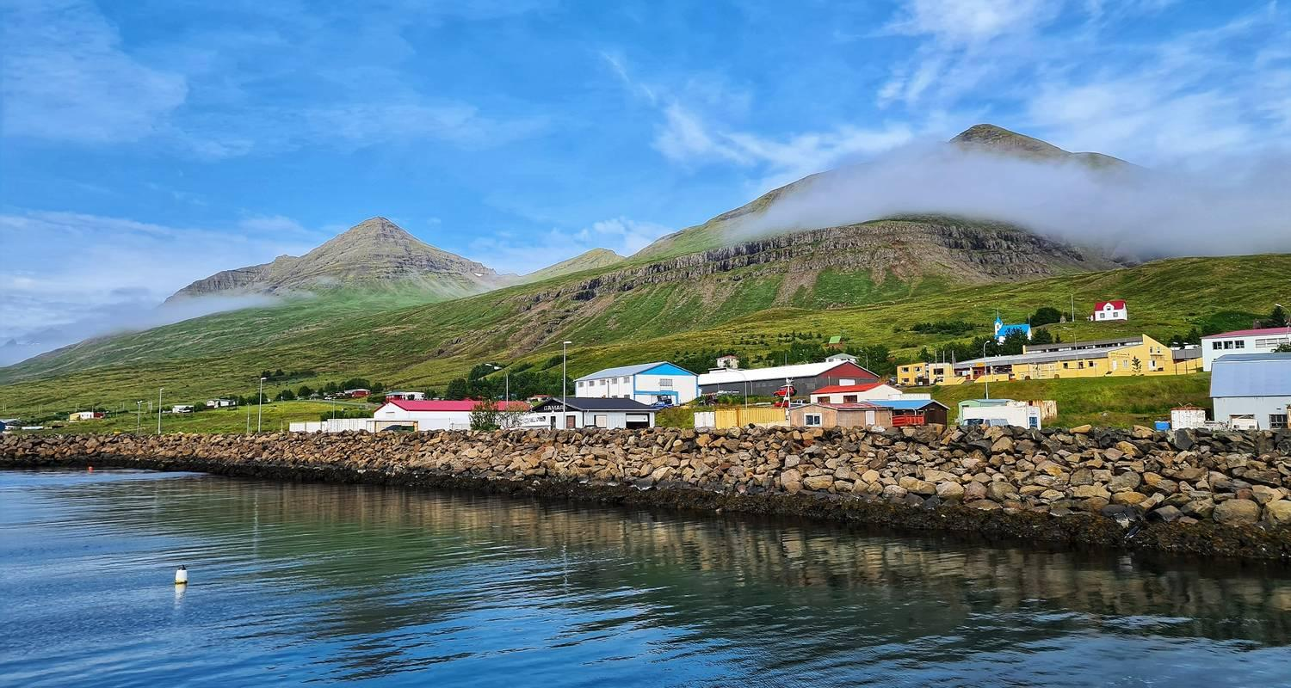

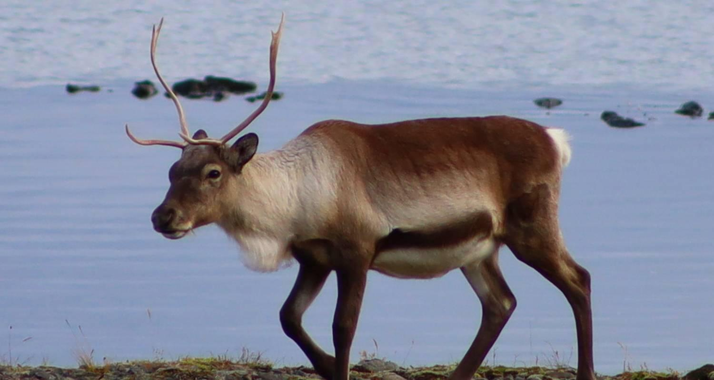

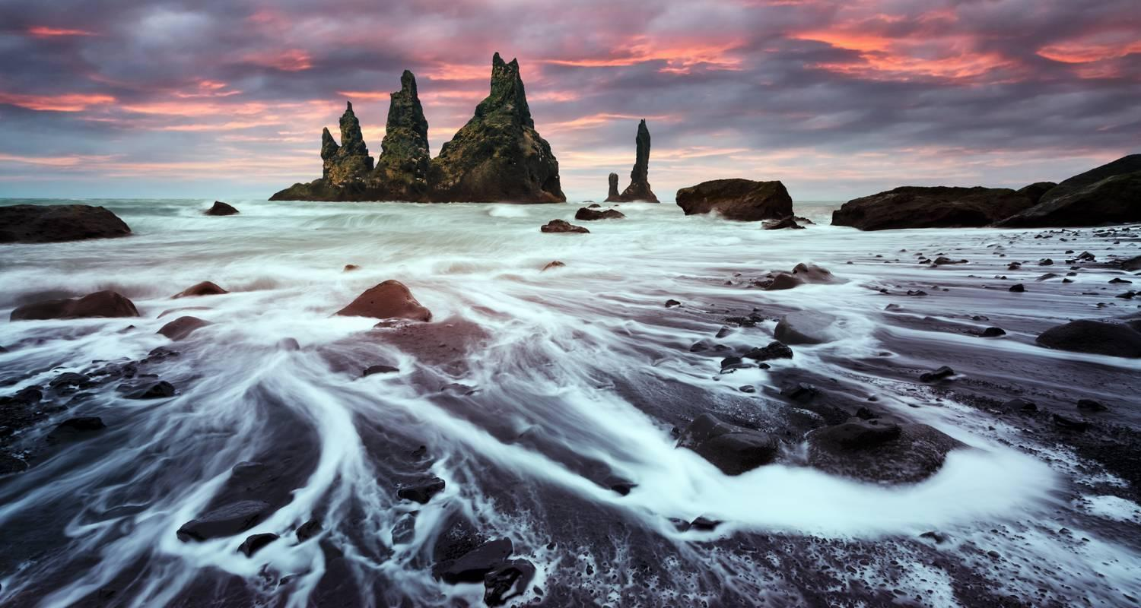

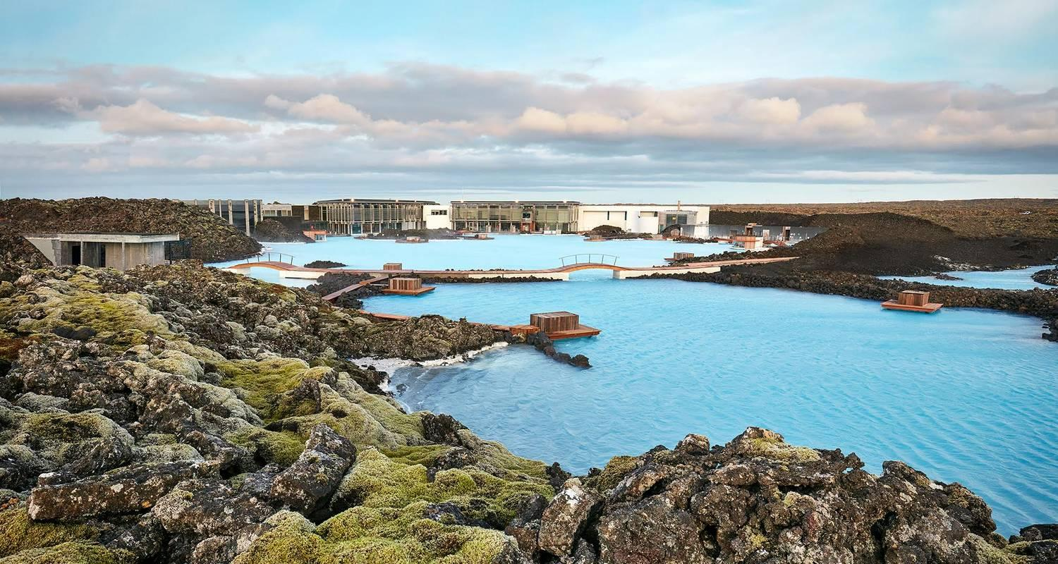

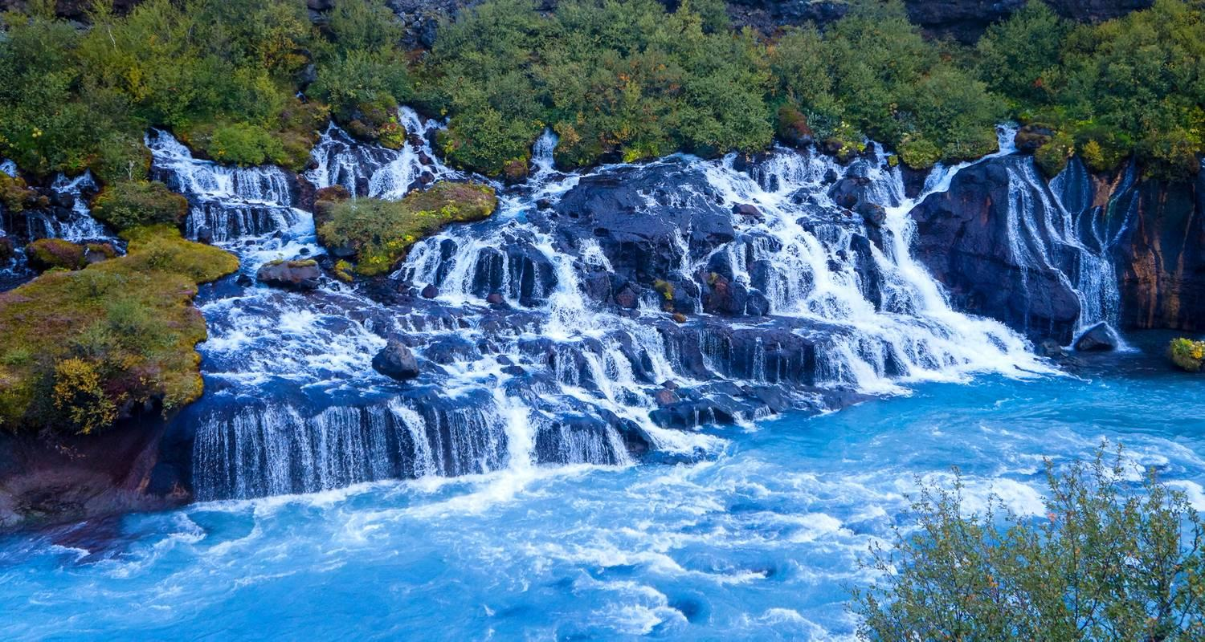

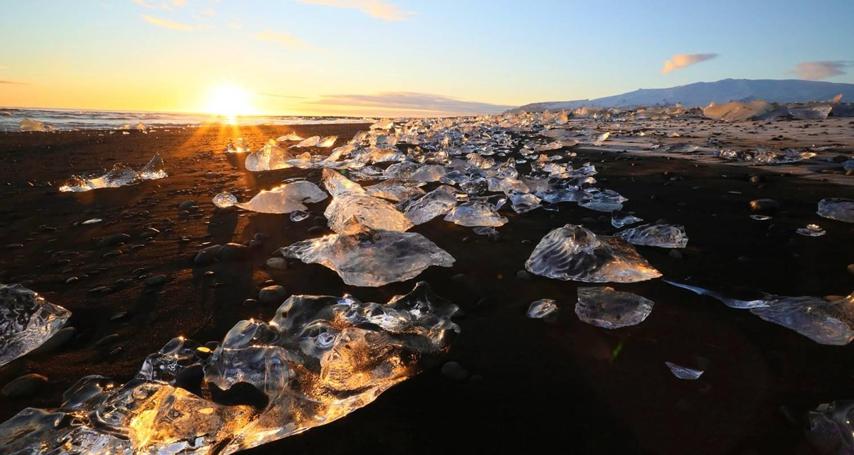

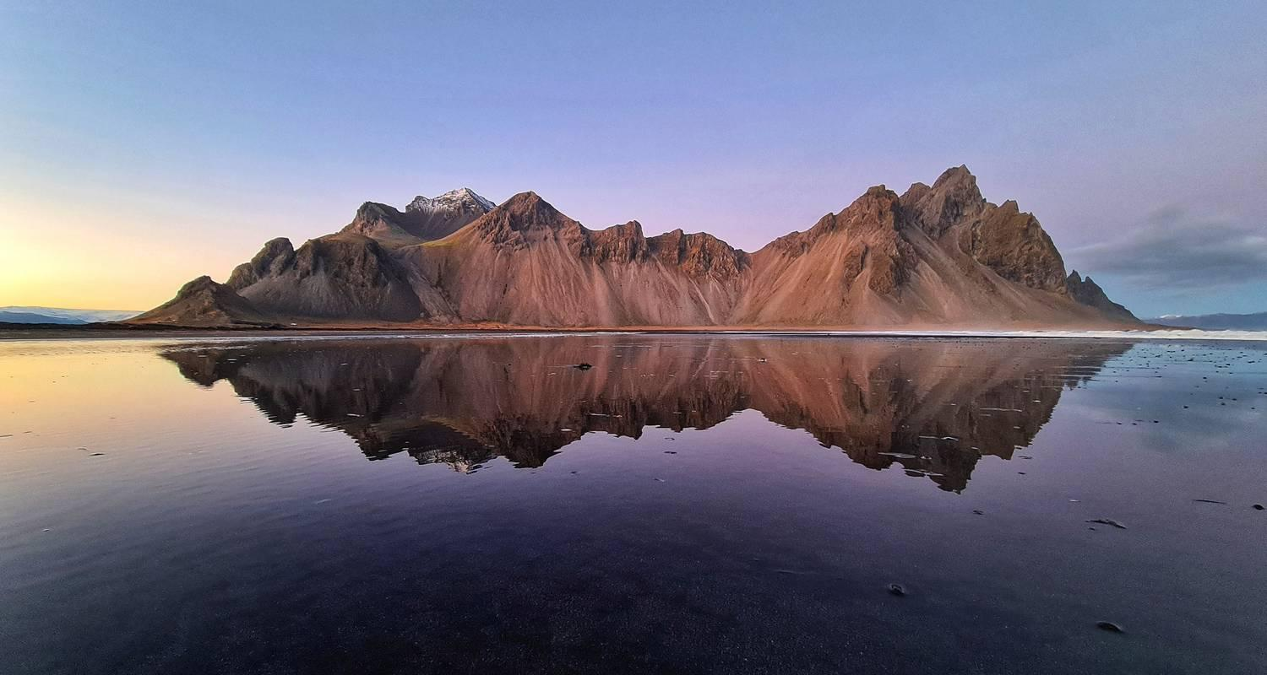

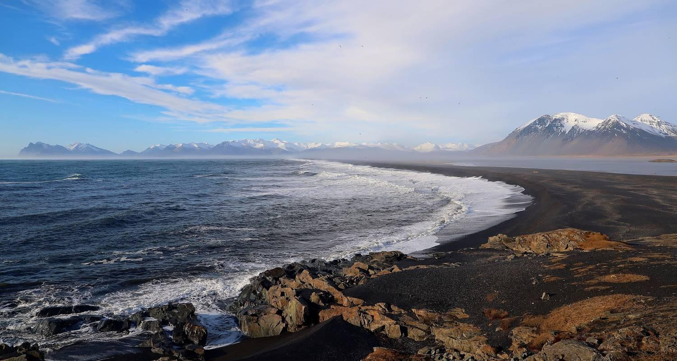

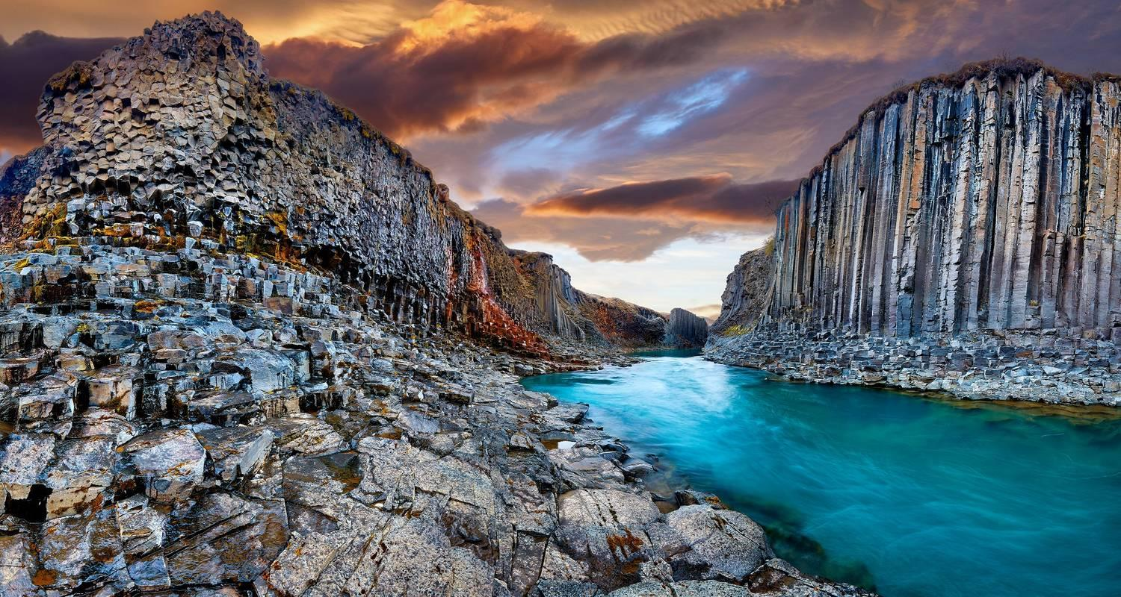

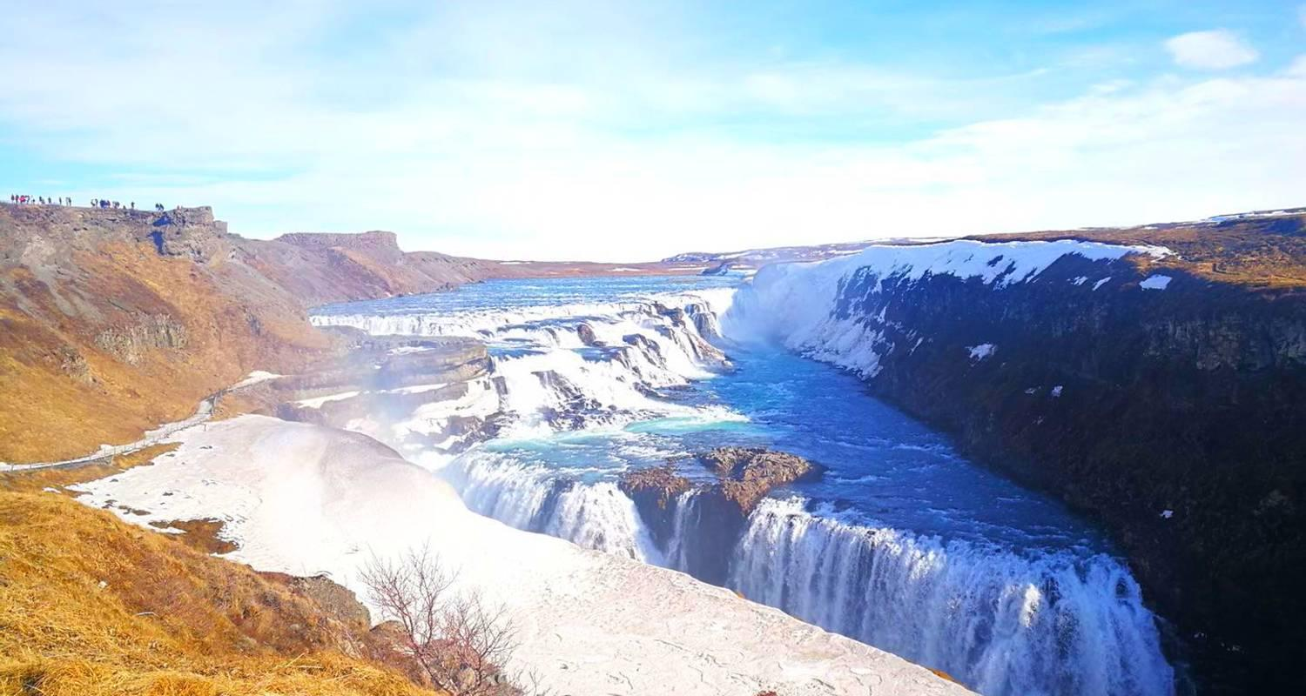

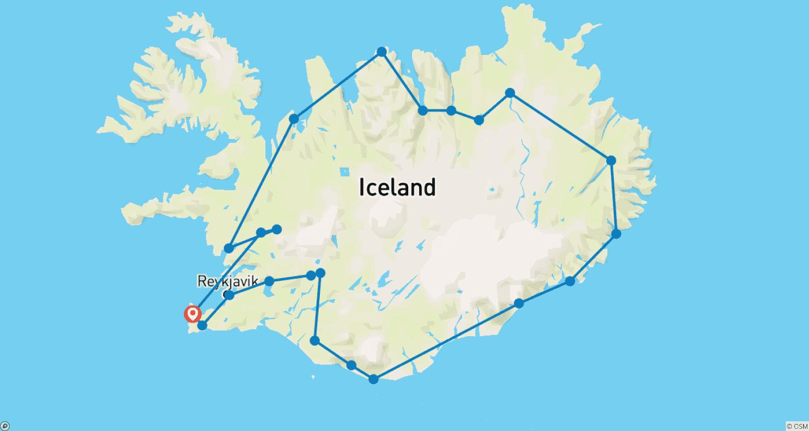

Tour ID: 217392  
Tour Name: 9 Days Ring Road & Golden Circle Complete Iceland - Private Tour

Tour destinations: ['Keflavik', 'Blue Lagoon', 'Borgarnes', 'Hvitserkur', 'Akureyri', 'Godafoss', 'Myvatn', 'Egilsstadir', 'Hofn', 'Jokulsarlon', 'Reynisfjara', 'Skogafoss', 'Thingvellir National Park', 'Geysir', 'Gullfoss', 'Reykjavik']

Tour destinations images:



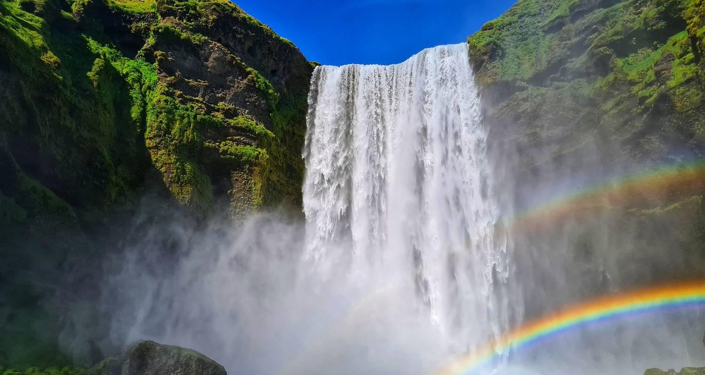

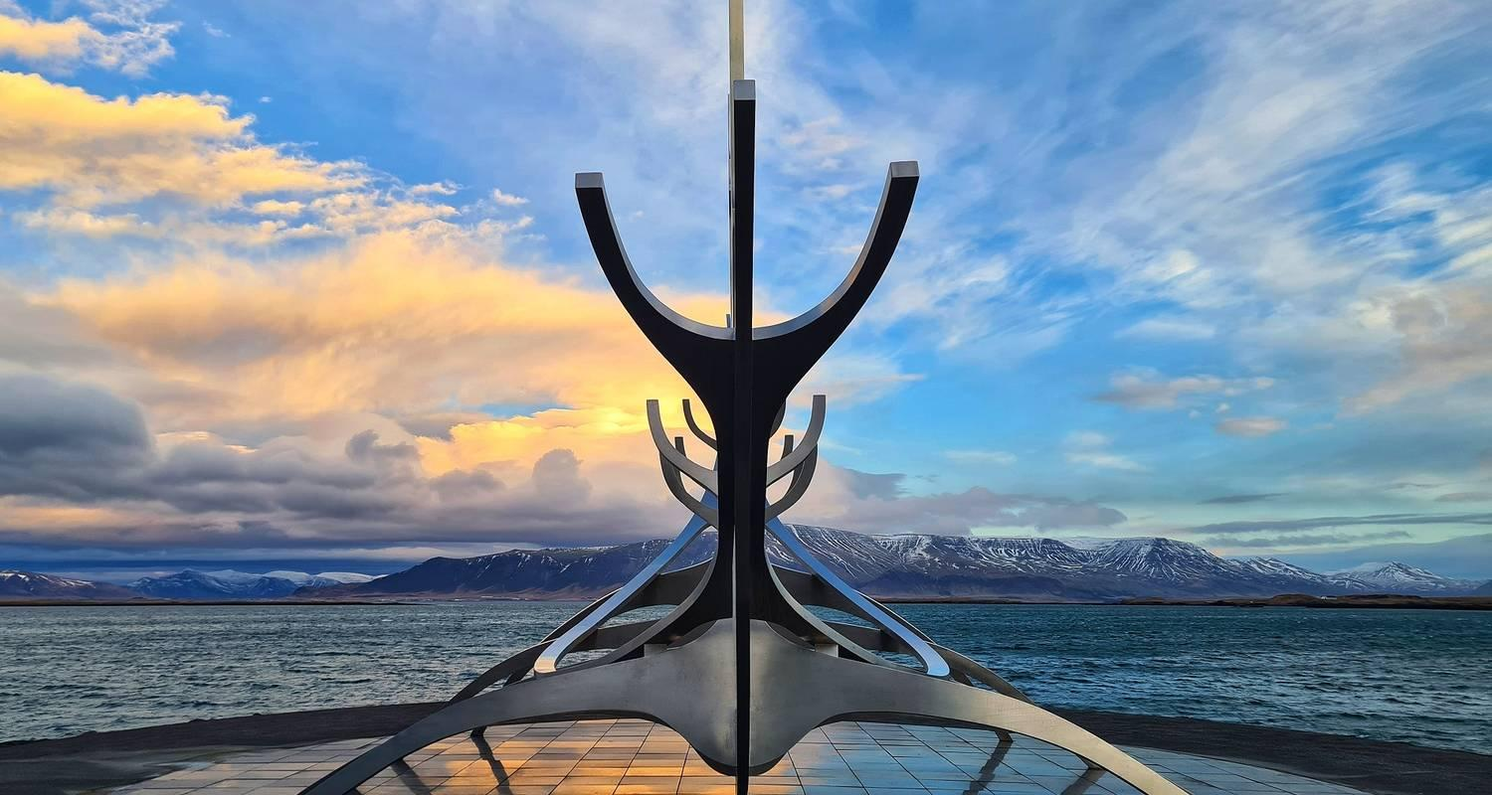

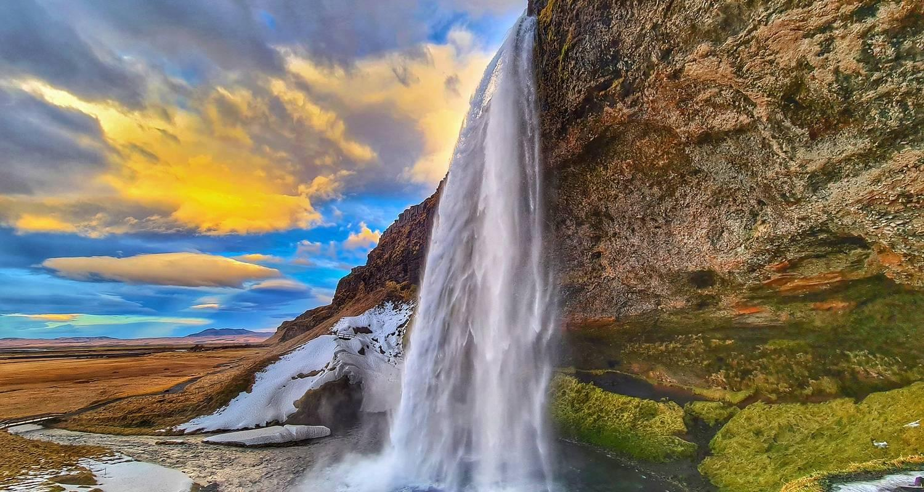

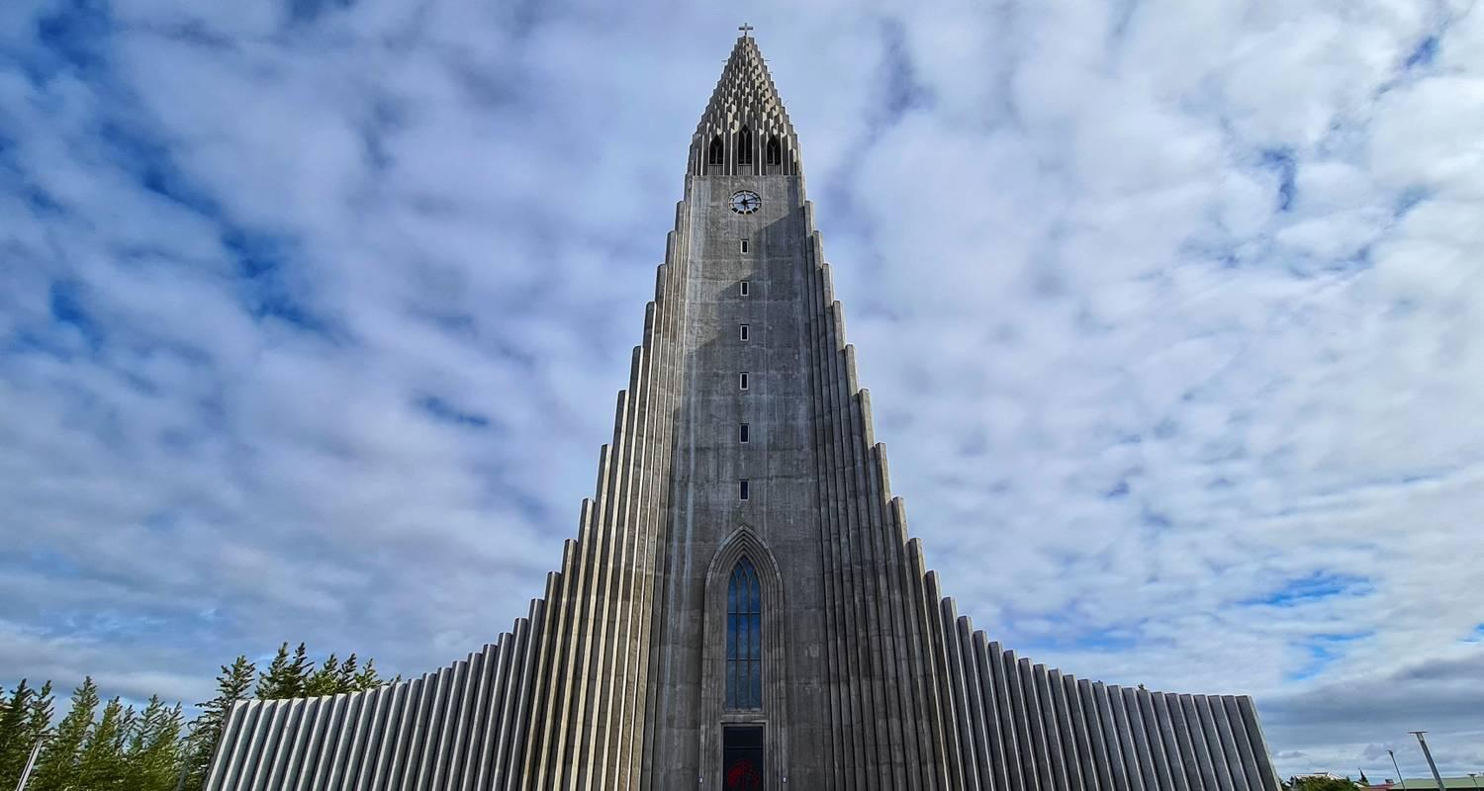

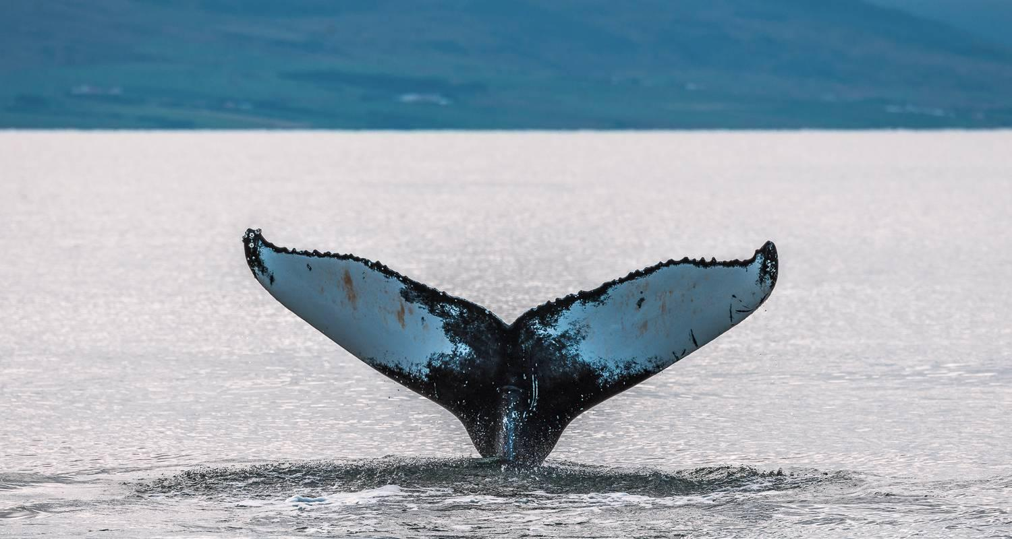

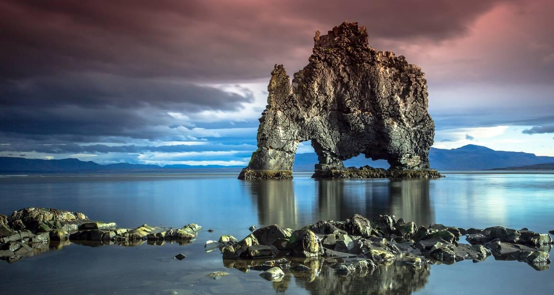

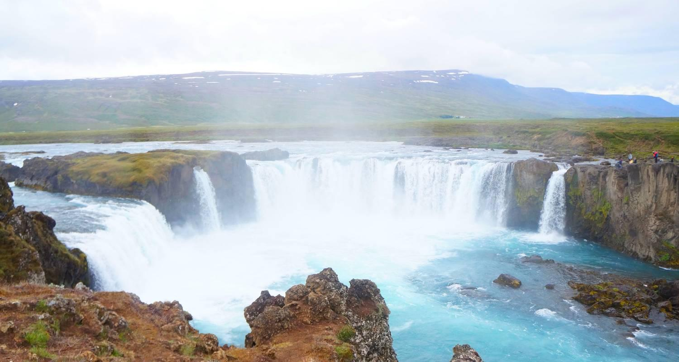

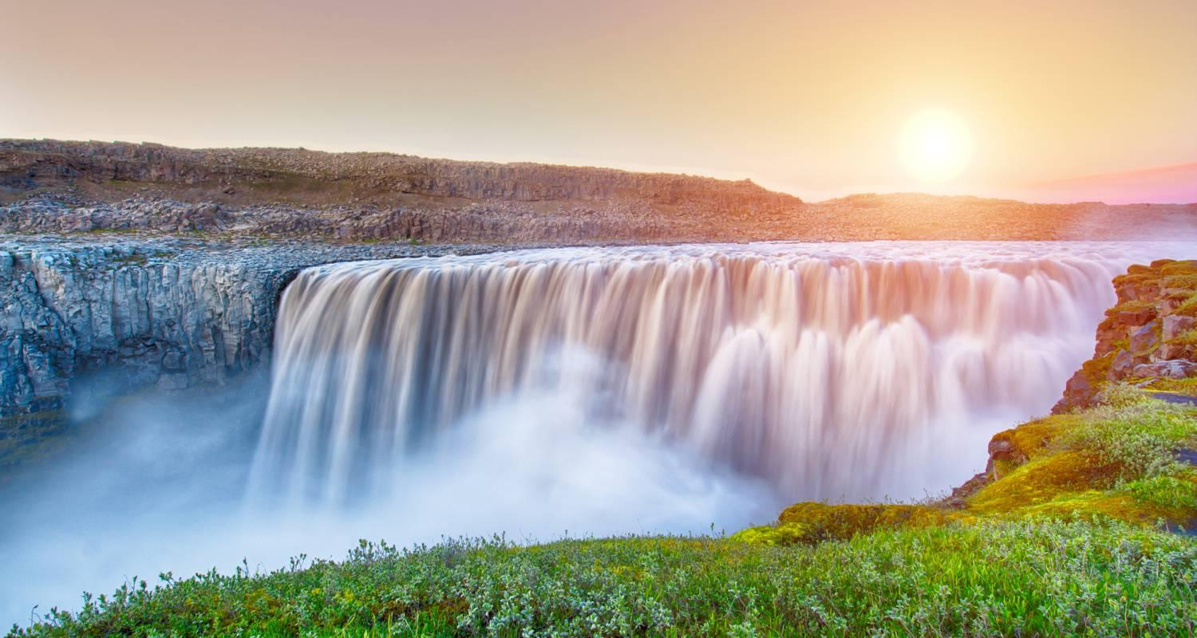

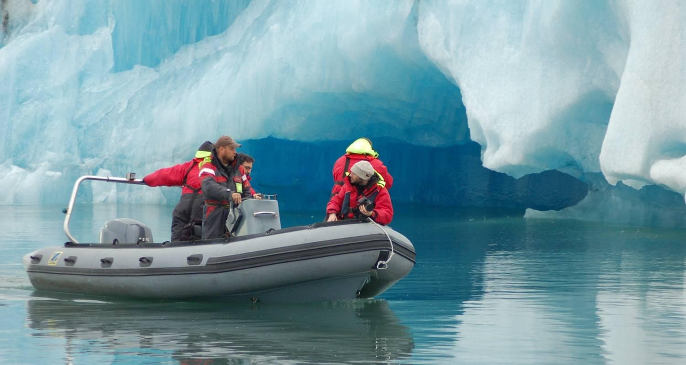

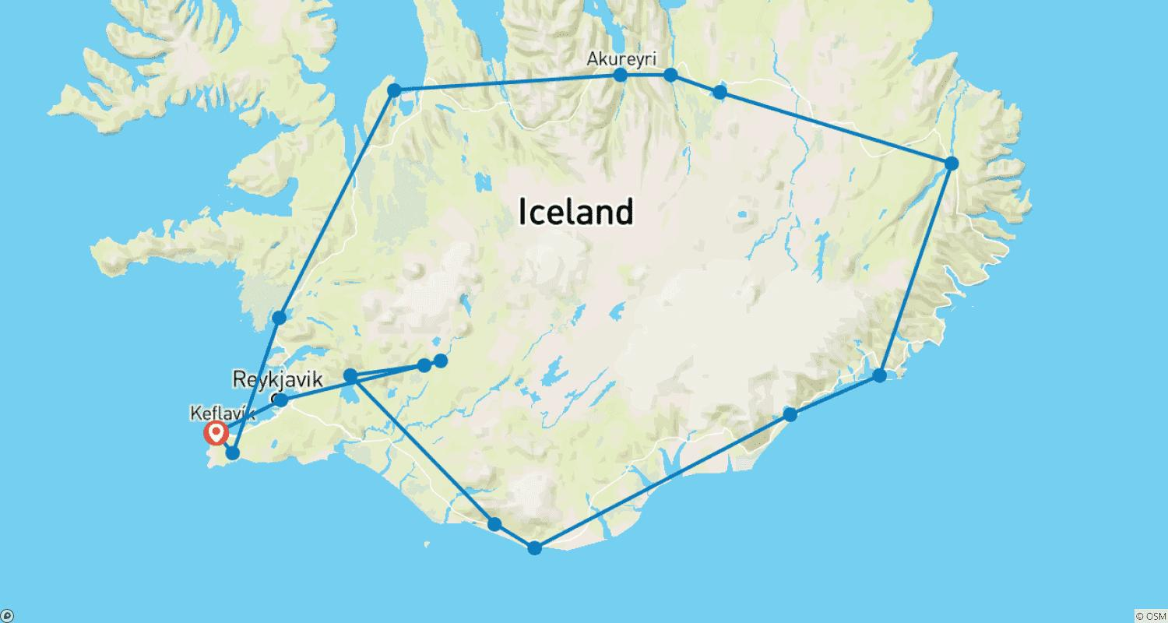

Tour ID: 217510  
Tour Name: 4 Days Golden Circle, South Coast and Snæfellsnes - Private tour

Tour destinations: ['Snæfellsnes', 'Reykjavik', 'Arnarstapi', 'Hellnar', 'Reykholt', 'Hraunfossar', 'Thingvellir National Park', 'Geysir', 'Gullfoss', 'Hvolsvollur', 'Skogafoss', 'Reynisfjara']

Tour destinations images:

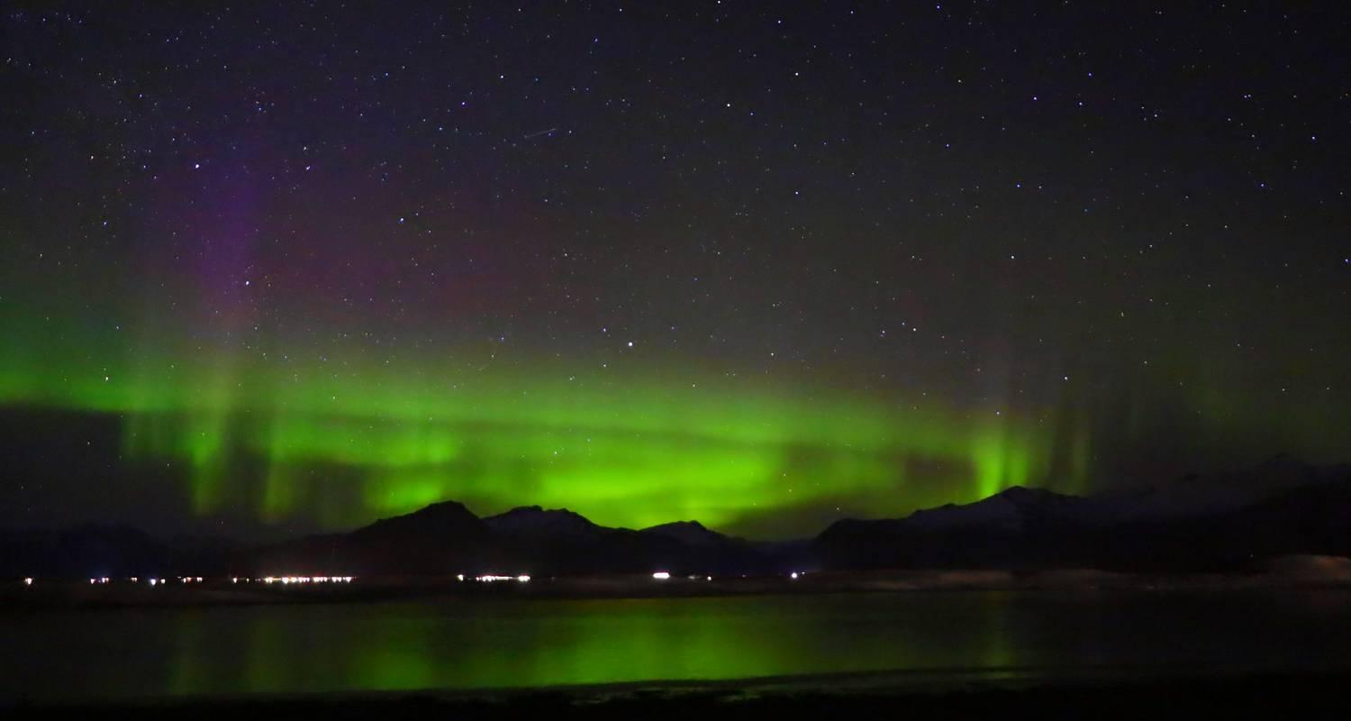





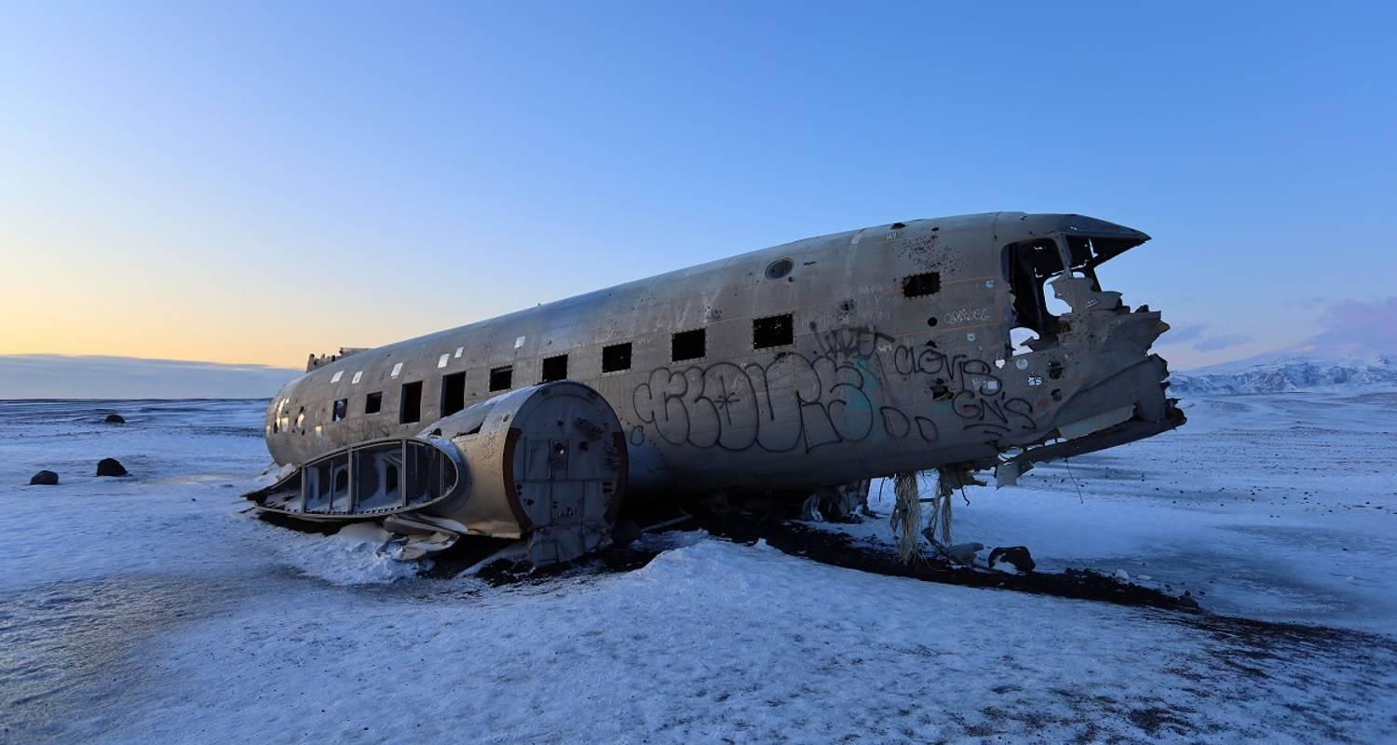



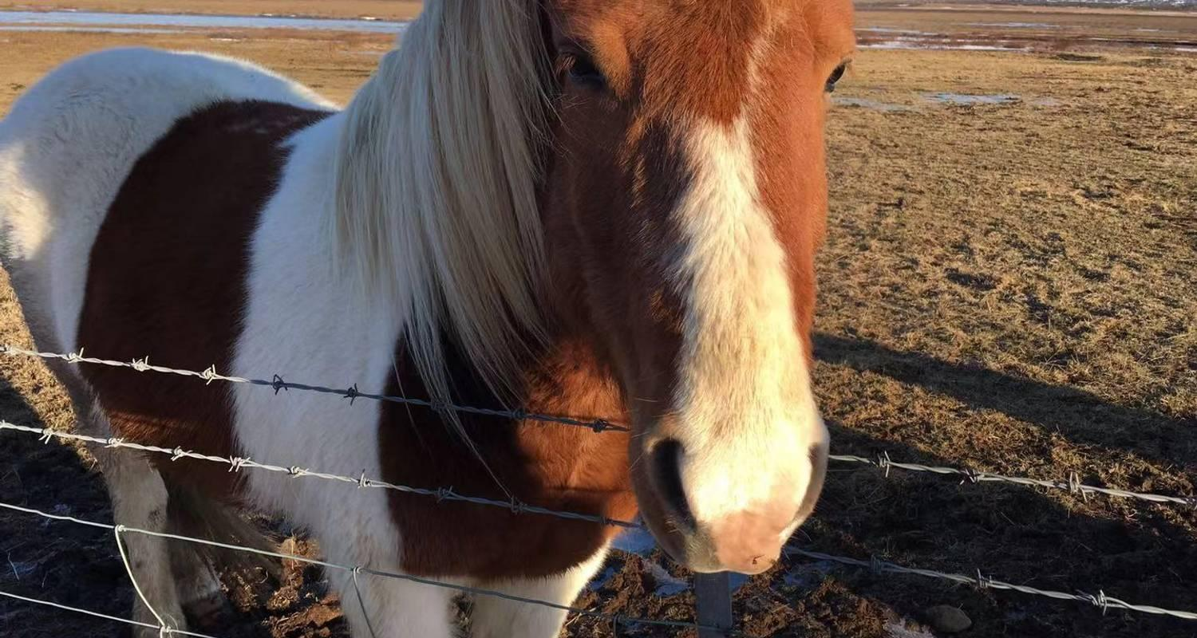



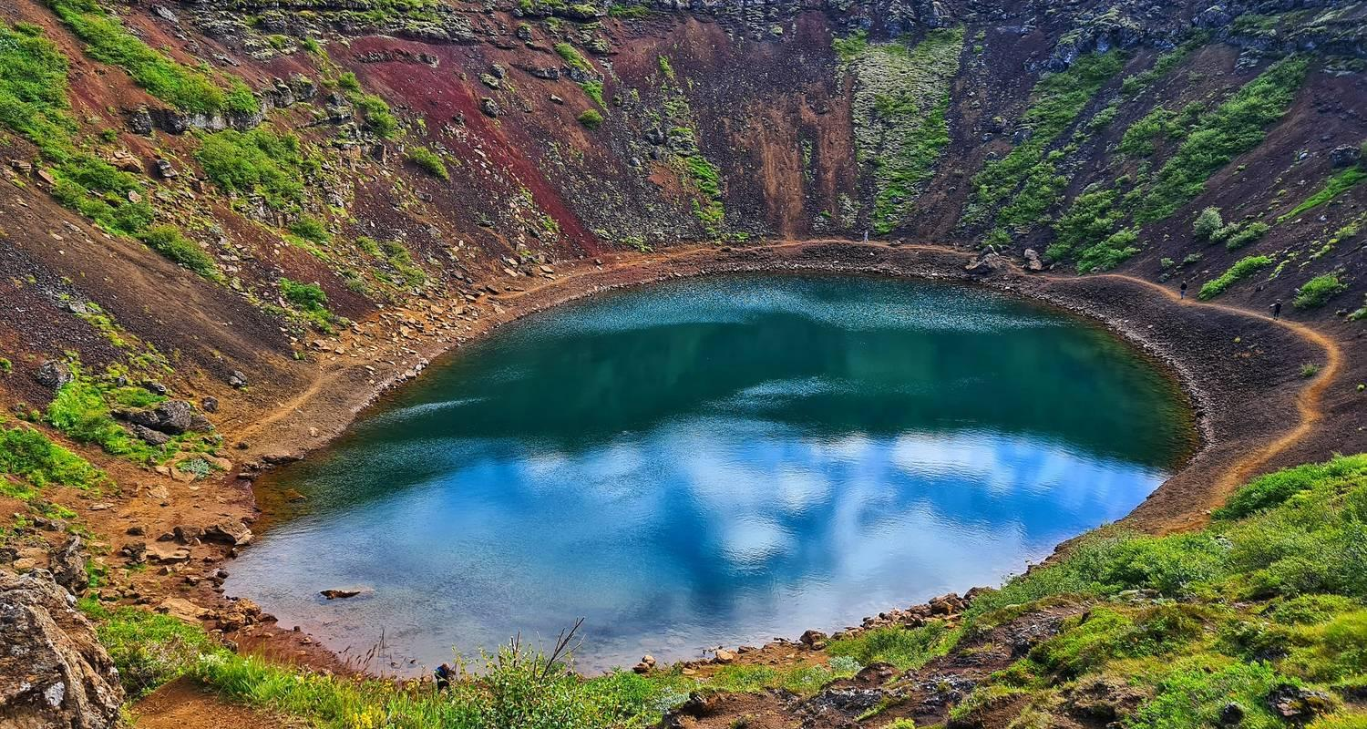

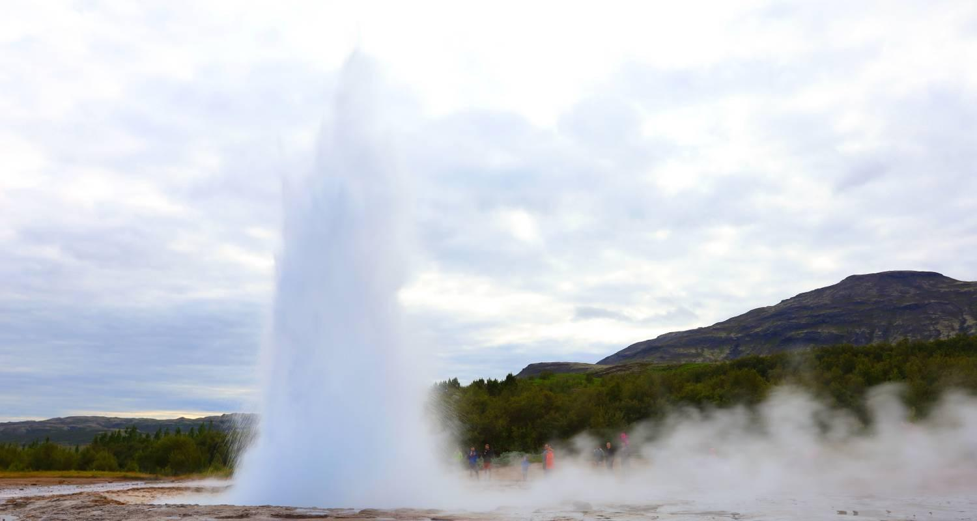

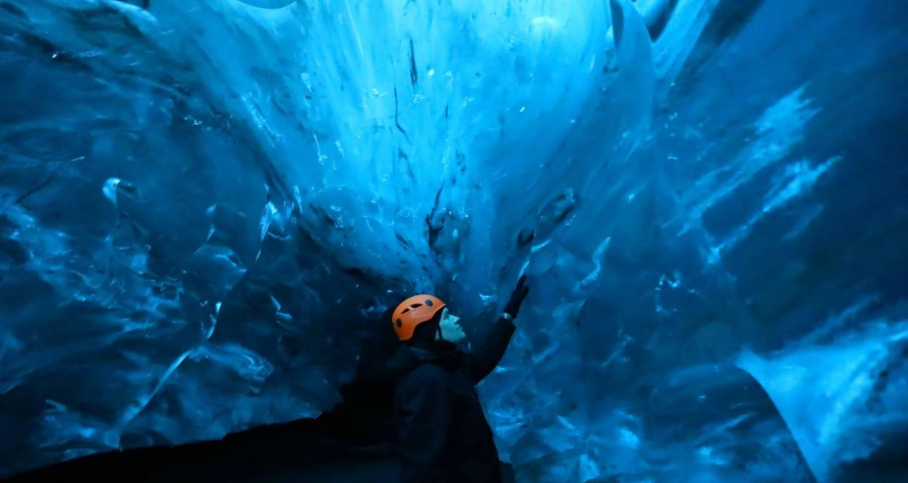

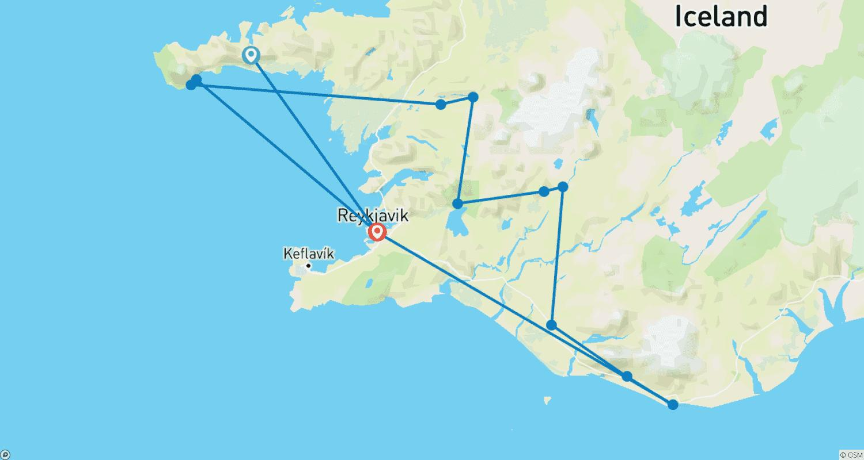

Tour ID: 217514  
Tour Name: 5 Days Reykjavik, Golden Circle and South Coast Tour - Private tour

Tour destinations: ['Keflavik', 'Blue Lagoon', 'Reykjavik', 'Thingvellir National Park', 'Geysir', 'Gullfoss', 'Hvolsvollur', 'Skogafoss', 'Reynisfjara']

Tour destinations images:



















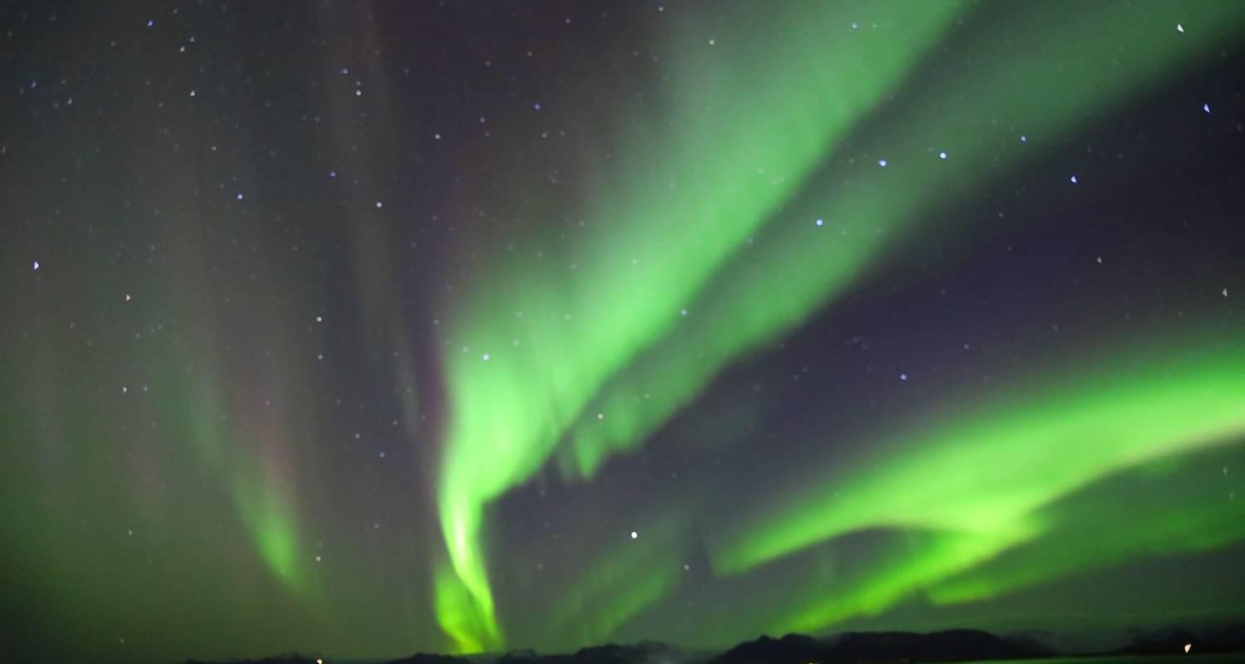

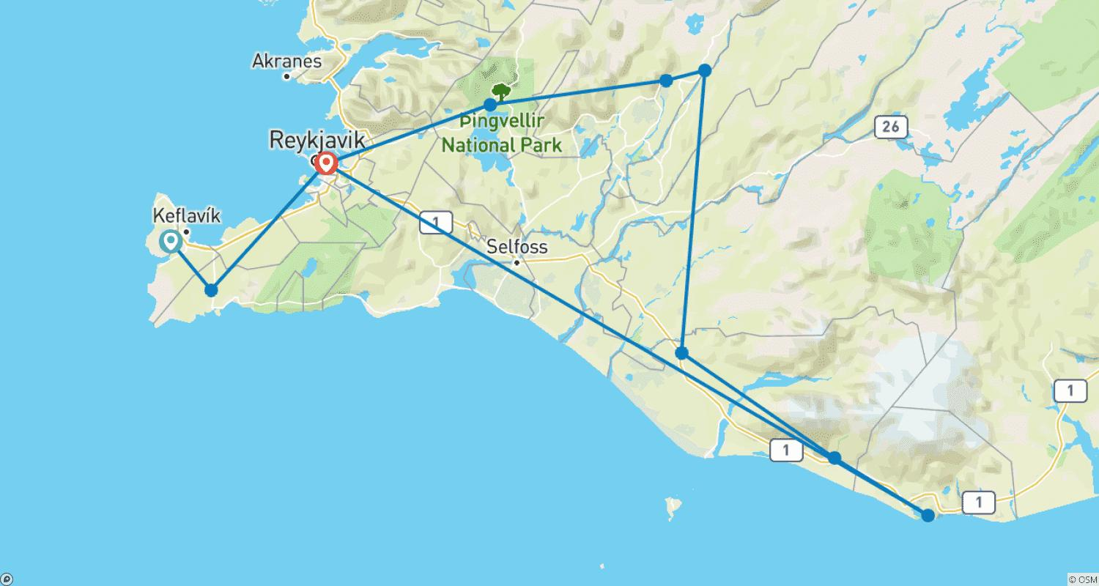

Tour ID: 217522  
Tour Name: 6 Days Reykjavik, Golden Circle and South Iceland Tour - Private tour

Tour destinations: ['Keflavik', 'Blue Lagoon', 'Reykjavik', 'Thingvellir National Park', 'Geysir', 'Gullfoss', 'Hvolsvollur', 'Skogafoss', 'Reynisfjara', 'Jokulsarlon']

Tour destinations images:

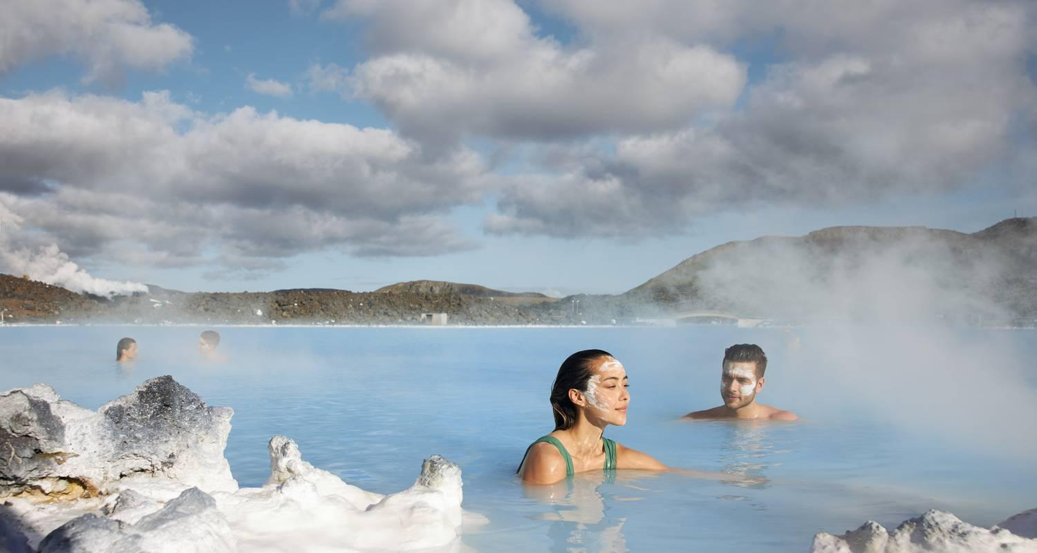

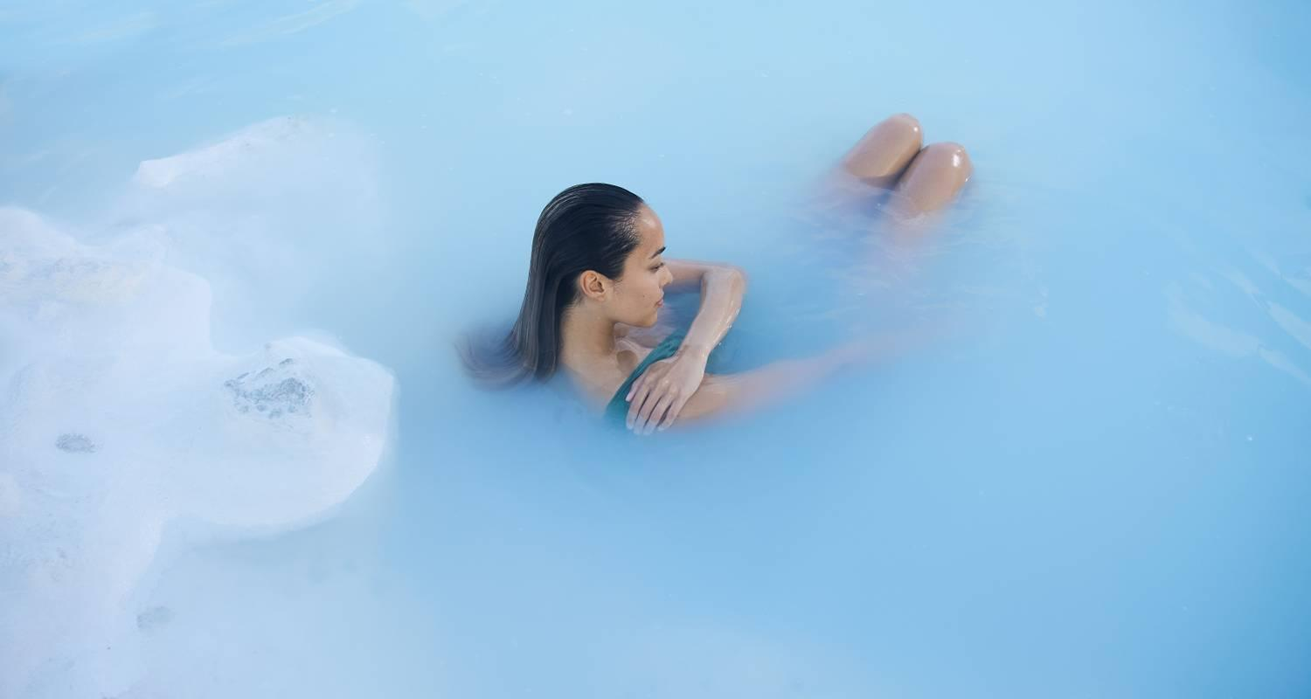

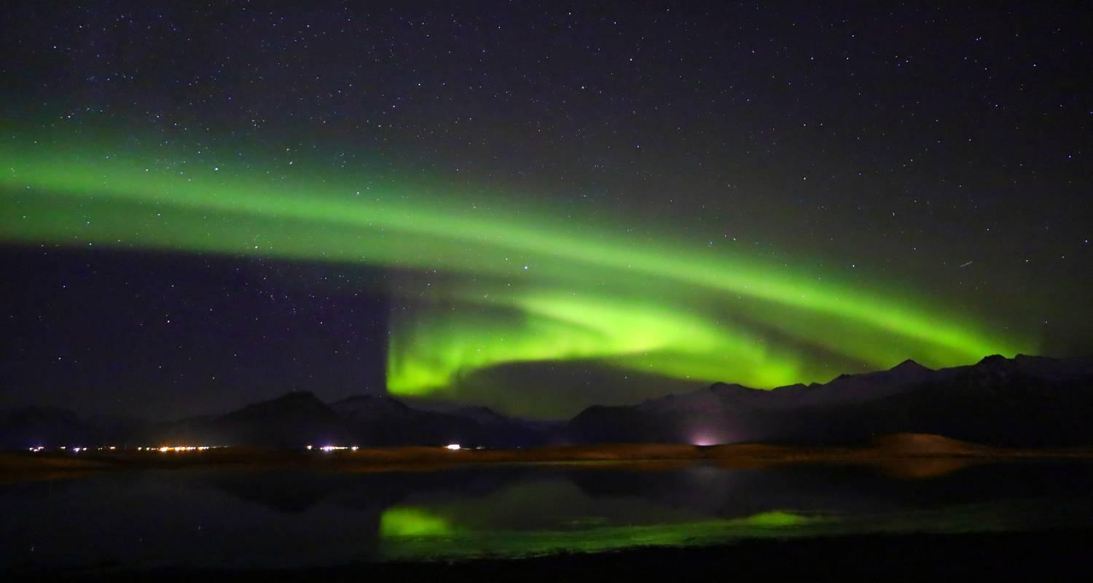















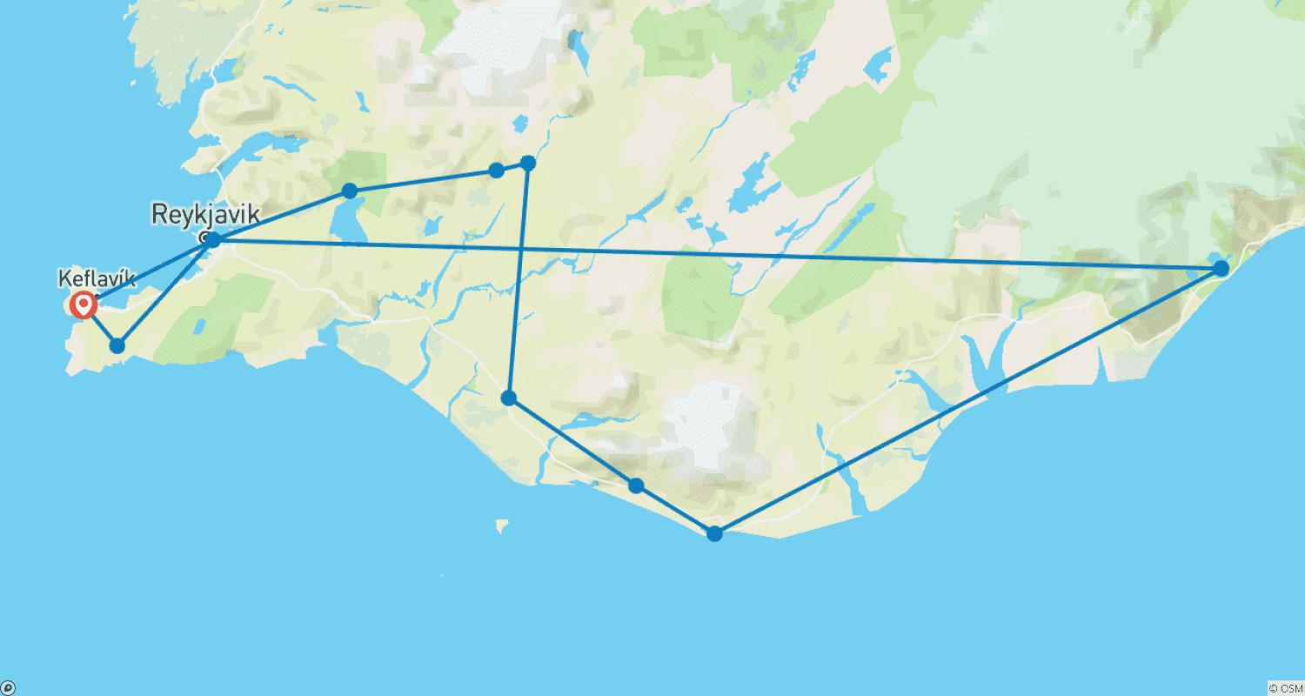

Tour ID: 217523  
Tour Name: 7 Days Golden Circle, South Coast, Snæfellsnes and Reykjavik - Private tour

Tour destinations: ['Keflavik', 'Blue Lagoon', 'Borgarnes', 'Arnarstapi', 'Kirkjufell Mountain', 'Reykholt', 'Thingvellir National Park', 'Geysir', 'Gullfoss', 'Hvolsvollur', 'Skogafoss', 'Reynisfjara', 'Jokulsarlon', 'Reykjavik']

Tour destinations images:

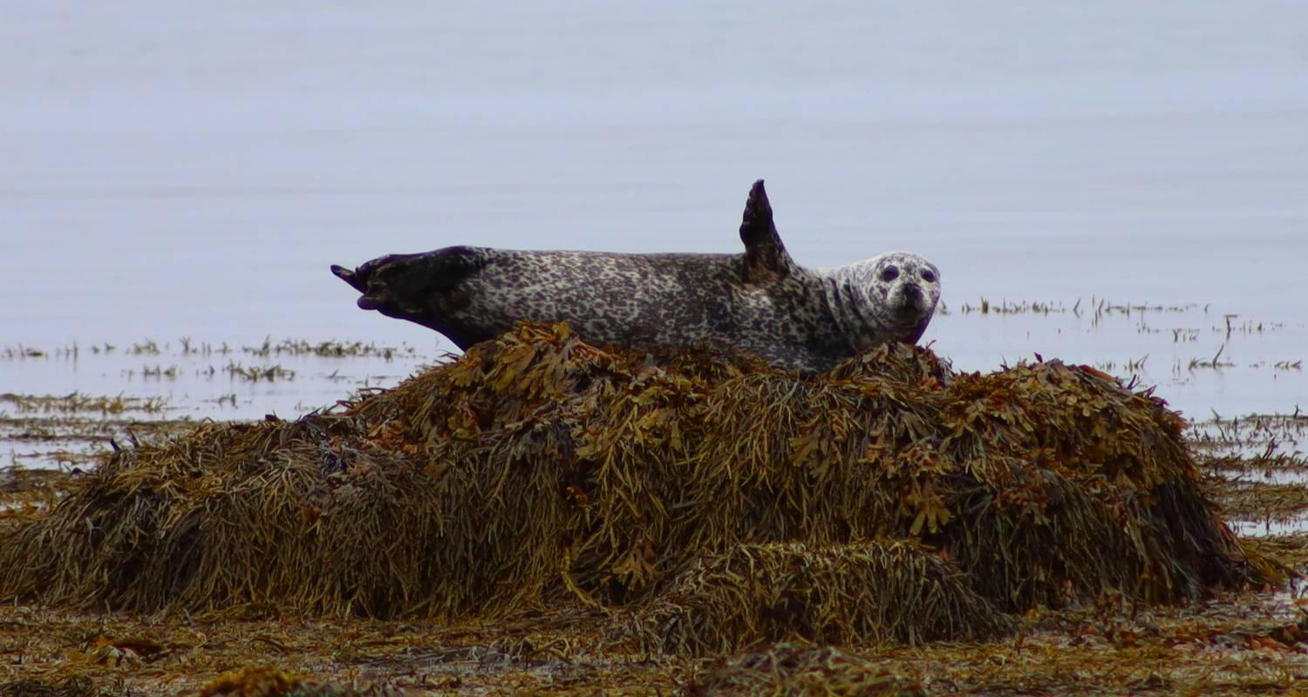



















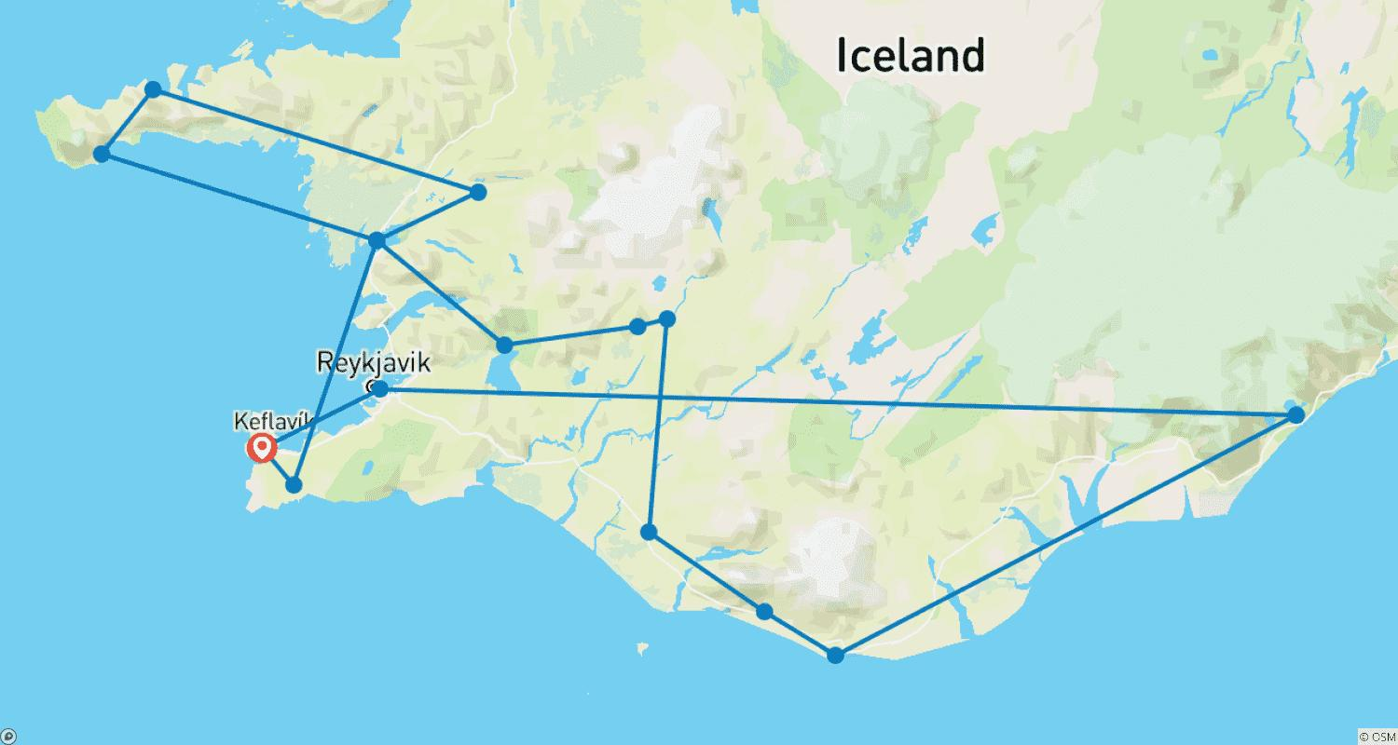

Tour ID: 217568  
Tour Name: 8 Days Around Iceland | Ring Road - Private Tour

Tour destinations: ['Keflavik', 'Reykjavik', 'Thingvellir National Park', 'Geysir', 'Gullfoss', 'Skogafoss', 'Reynisfjara', 'Vik', 'Jokulsarlon', 'Egilsstadir', 'Myvatn', 'Mount Namaskard', 'Godafoss', 'Akureyri', 'Blue Lagoon']

Tour destinations images:

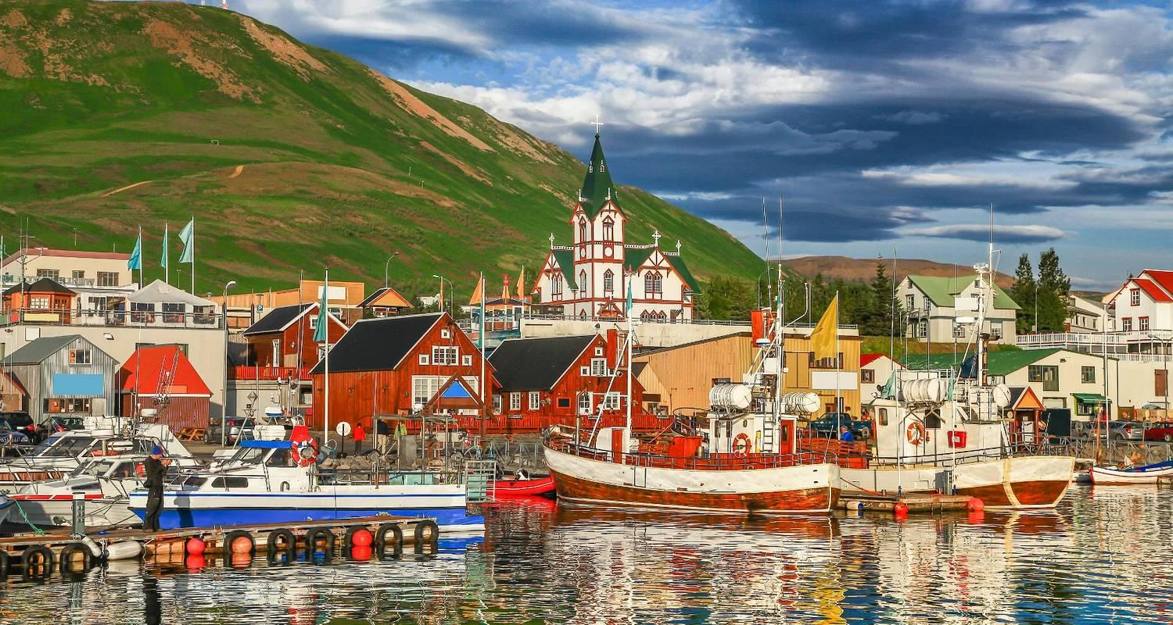

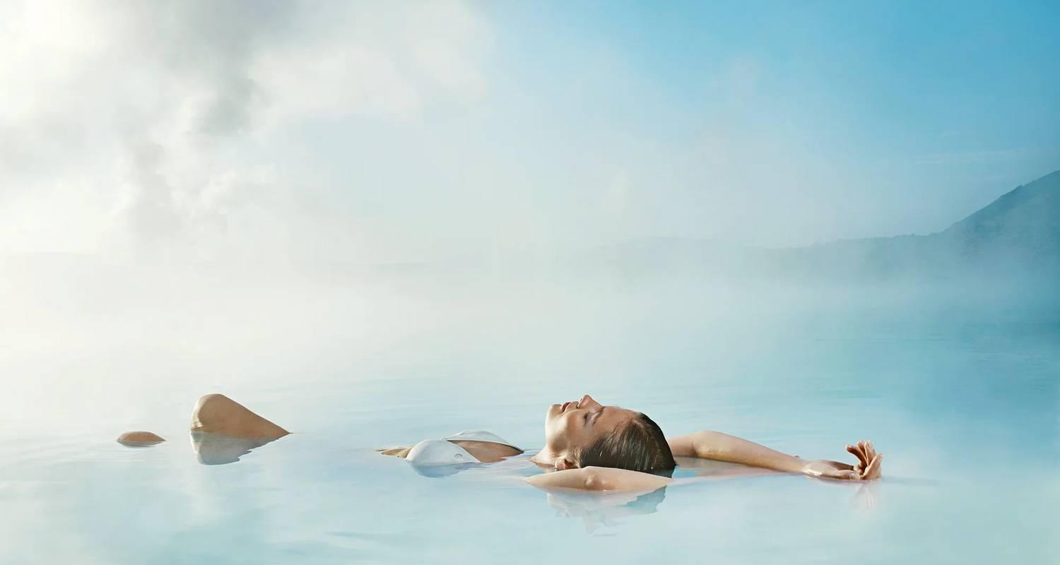

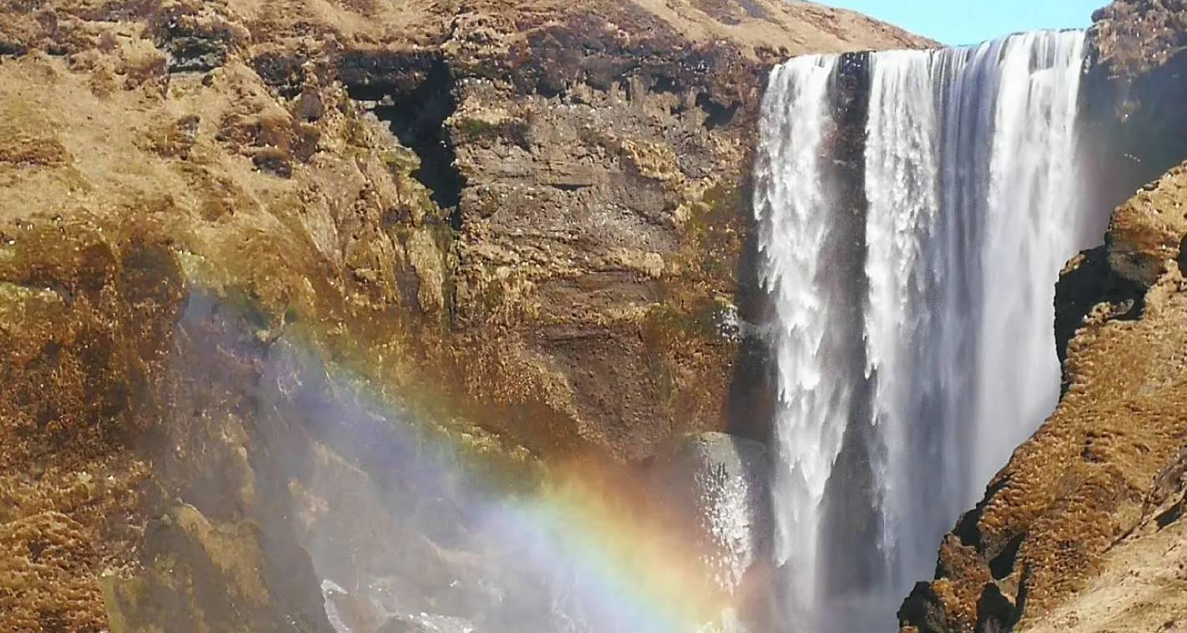

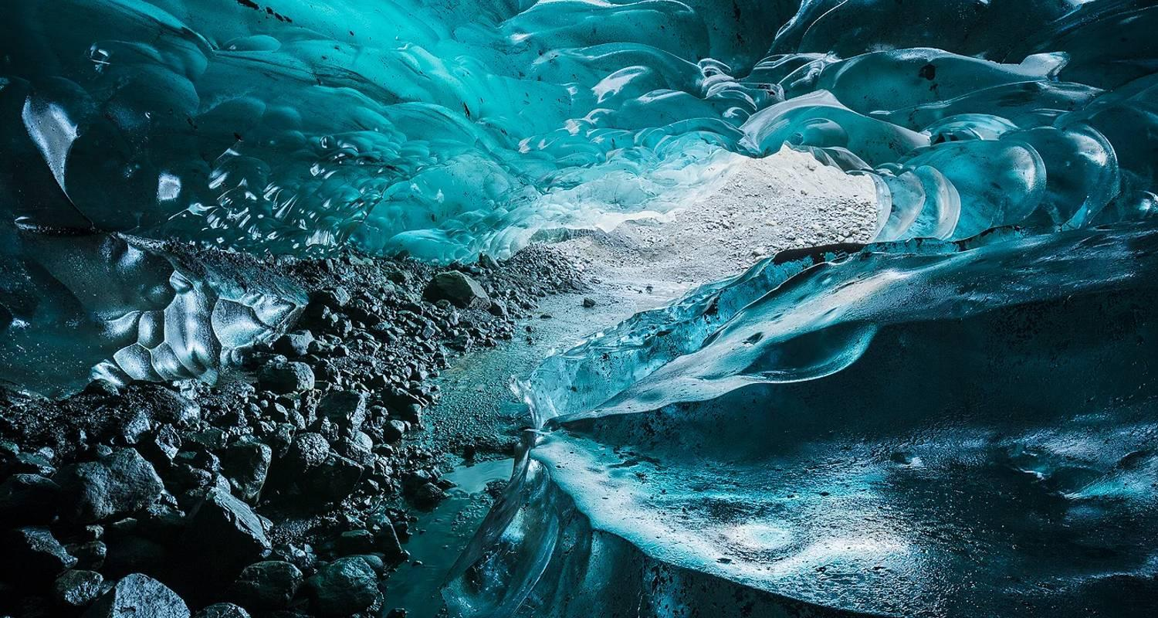

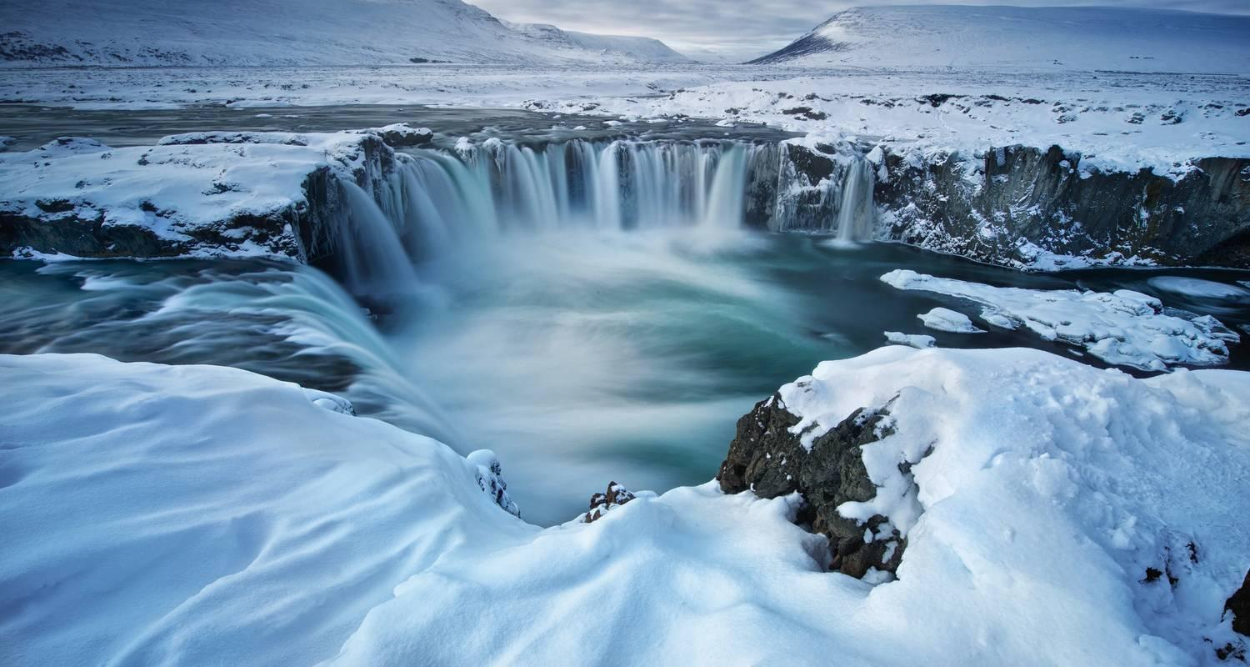

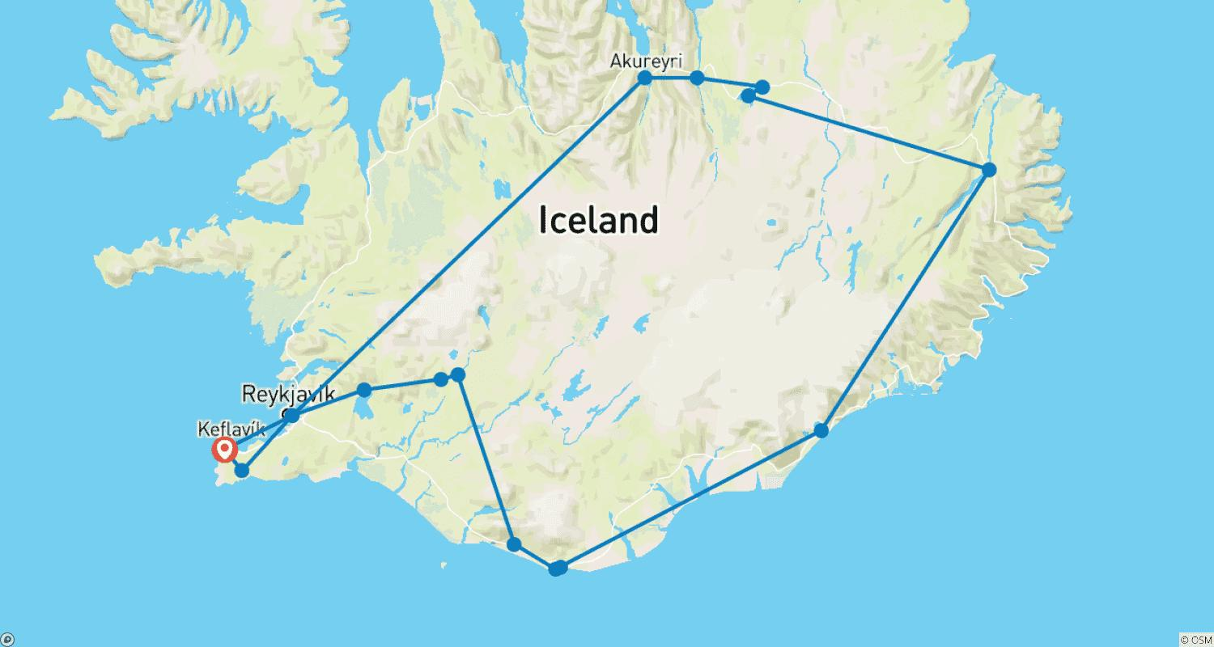

Tour ID: 217569  
Tour Name: 10 Days Iceland Ring Road In-depth - Private Tour

Tour destinations: ['Keflavik', 'Blue Lagoon', 'Borgarnes', 'Arnarstapi', 'Kirkjufell Mountain', 'Reykholt', 'Hvitserkur', 'Akureyri', 'Godafoss', 'Myvatn', 'Dettifoss', 'Egilsstadir', 'Hofn', 'Jokulsarlon', 'Reynisfjara', 'Skogafoss', 'Thingvellir National Park', 'Geysir', 'Gullfoss', 'Reykjavik']

Tour destinations images:





















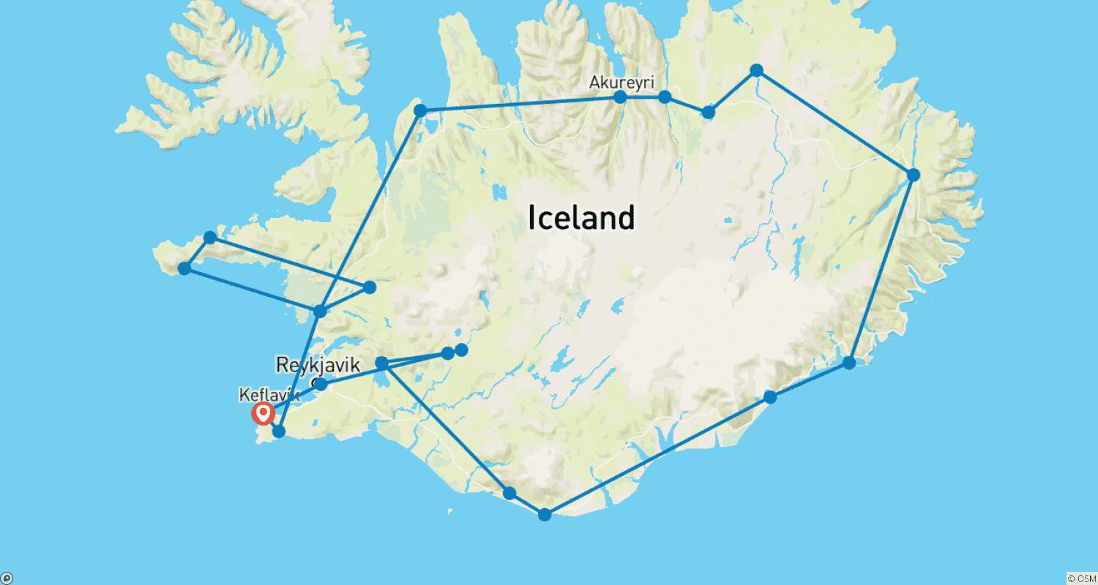

Tour ID: 217570  
Tour Name: 11 Days Ultimate Iceland Ring Road - Private Tour

Tour destinations: ['Keflavik', 'Blue Lagoon', 'Borgarnes', 'Arnarstapi', 'Kirkjufell Mountain', 'Reykholt', 'Hvitserkur', 'Akureyri', 'Godafoss', 'Myvatn', 'Egilsstadir', 'Hofn', 'Jokulsarlon', 'Svartifoss', 'Reynisfjara', 'Skogafoss', 'Kerid Volcano', 'Thingvellir National Park', 'Geysir', 'Gullfoss', 'Reykjavik']

Tour destinations images:

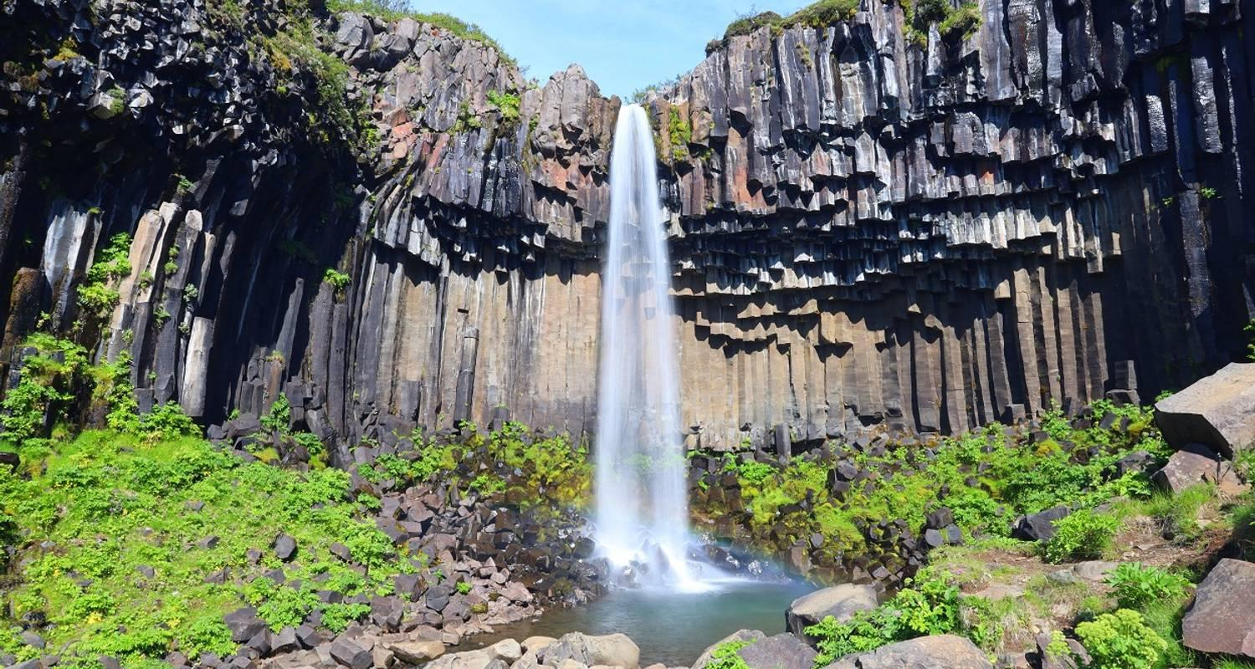







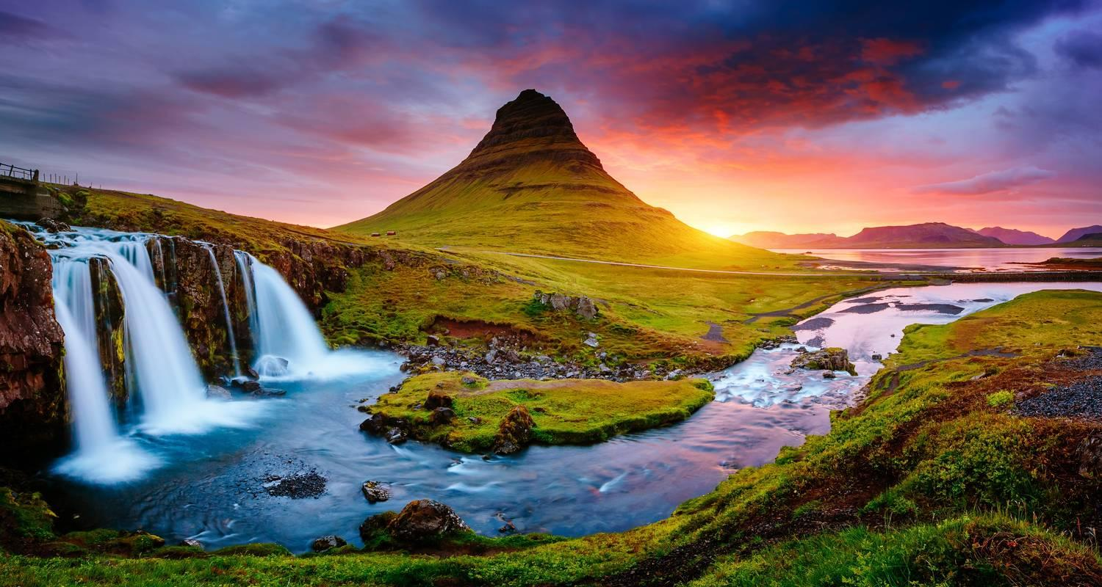

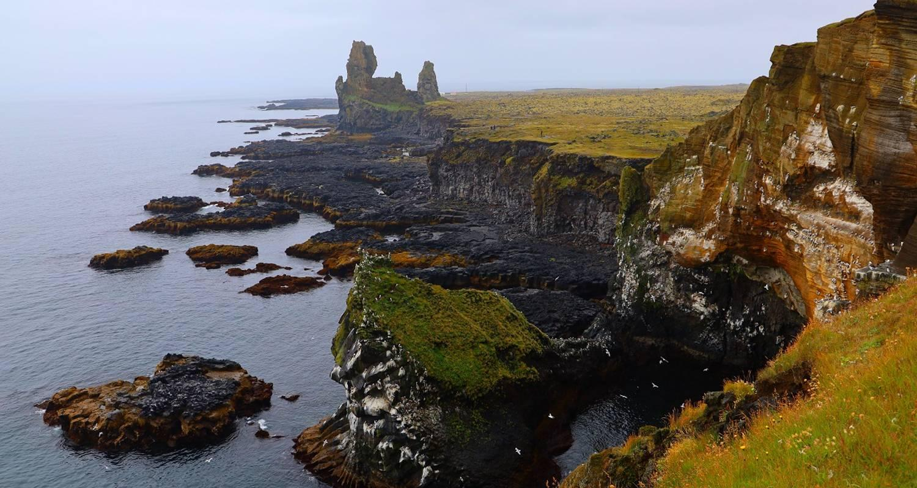



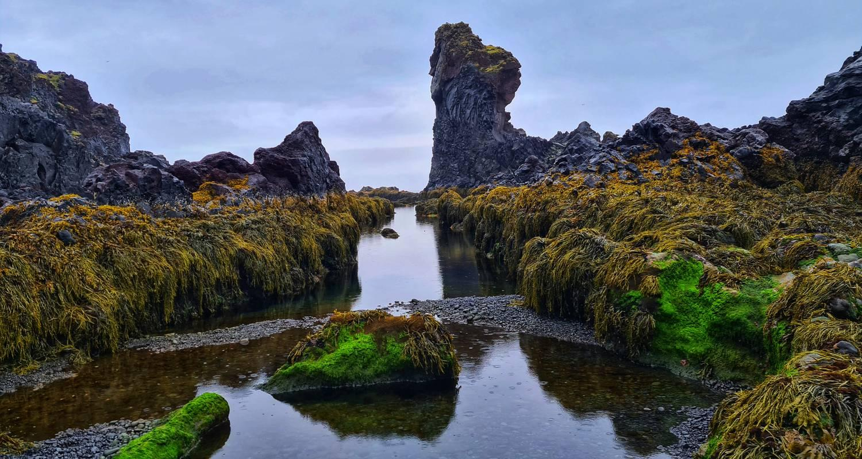

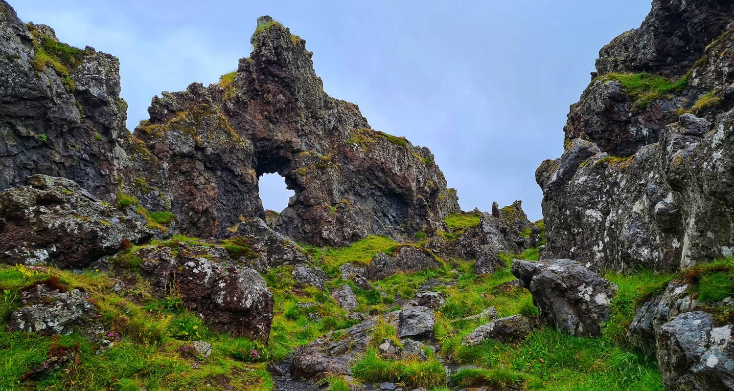



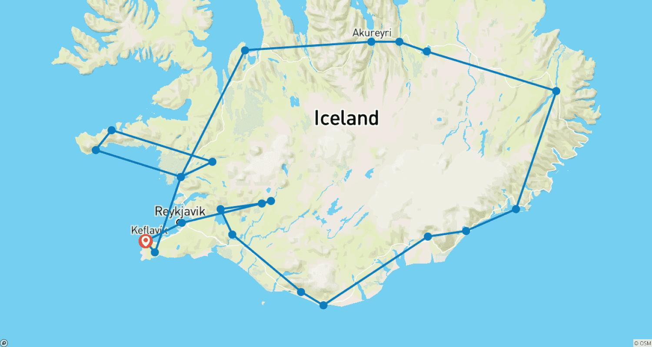

Tour ID: 217618  
Tour Name: 6 Days Self-drive | Reykjavik, Golden Circle and South Iceland Tour

Tour destinations: ['Keflavik', 'Blue Lagoon', 'Reykjavik', 'Thingvellir National Park', 'Geysir', 'Gullfoss', 'Skogafoss', 'Reynisfjara', 'Jokulsarlon', 'Kirkjubaejarklaustur']

Tour destinations images:



















